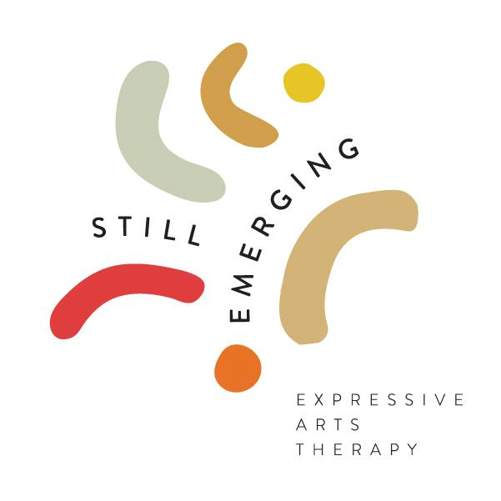

Telemental Health Counseling Consent

Distance and remote therapy sessions will be offered as needed. Both therapist and client agree to be in a private space, free of distractions, interruptions, and away from other people that may be occupying spaces within the location of the telemental health session. No other party shall participate off screen in the session unless they are a parent/guardian of a child under the age of 9yrs old. Clients will inform therapist if they are in another location different from their home address on file.

By consenting for treatment you understand that telemental health treatment consists of individual/family expressive arts therapy, consulting, and distance reiki treatments. The laws and limitations that protect the confidentiality of personal health information also apply to distance treatment (see below for more details on confidentiality).

There are risks and consequences from distance expressive arts therapy, including, but not limited to, the possibility, despite reasonable efforts on the part of Still Emerging Expressive Arts Therapy, LLC, that: the transmission of my personal information could be disrupted or distorted by technical failures; the transmission of my personal information could be interrupted by unauthorized persons; and/or the electronic storage of my personal information could be accessed by unauthorized persons.

This therapist will never record any virtual counseling session(s), and asks that the consumer of this health care make no recording, either. It is important to note that there may be limitations of distance counseling that might affect the quality of the session(s). These limitations could include but are not limited to the following:
1. Therapist cannot see you, your body language, or your non-verbal reactions to what is being discussed.
2. Due to technology limitations, therapist may not hear all of what you are saying and may need to ask you to repeat things.
3. Technology might fail before or during the counseling session.
4. Although every effort is made to reduce confidentiality breaches, breaches may occur for various reasons.
5. To reduce the effect of these limitations, therapist may ask you to describe how you are feeling, thinking, and/or acting in more detail than I would during a face-to-face session. You may also feel that you need to describe your feelings, thoughts, and/or actions in more detail than you would during a face-to-face session.

I have read and understood the information provided above. I have discussed it with my psychotherapist, and all of my questions have been answered to my satisfaction.

Individual or Legal Guardian (please print) | Date

Signature of Individual or Legal Guardian | Date

Signature of Therapist | Date

